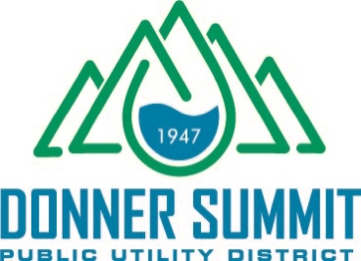

FOR IMMEDIATE RELEASE | CONTACT: SCHAELENE ROLLINS FOR DSPUD
JULY 30, 2020 | 916.397.1915 * SCHAELENE@PANDOPUBLICRELATIONS.COM

DONNER SUMMIT PUBLIC UTILITY DISTRICT TO SUPPLY RECYCLED WATER FOR DUST CONTROL MEASURES
Recycled water will be used for the Donner Pass Road Improvement Project

SODA SPRINGS, Calif. – August 3, 2020 – Donner Summit Public Utility District (DSPUD/District) has been secured a permitted to supply recycled water for dust control along a 6.5 mile stretch of road construction on Donner Pass Road. Herback General Engineering originally approached the District to purchase potable water for dust control, which is what prompted DSPUD to request a permit to sell recycled water instead.
“We had a fairly dry winter and conservation measures are in effect. Using recycled water seemed the prudent thing to do to conserve our potable water supply,” says Tom Skjelstad, general manager. “We already have a permit to make snow using recycled water so why not for dust control.”
The District completed a major upgrade to its wastewater treatment plant 2015, which resulted in a process that uses tertiary treatment with membrane bioreactors and ultraviolet disinfection to treat wastewater. The discharge permit obtained in 2015 allows tertiary treated water to be used for surface water discharge, land application and snow-making. The permit has been amended to include dust control.
DSPUD anticipates supplying up to 40,000 gallons of water per day for the Donner Pass Road Improvement Project during peak construction times when dust mitigation measures are in full effect. The use of recycled water will be in full compliance with safety precautions as permitted under Order # R5-2018-0085 issued by the Central Valley Regional Water Quality Control Board.
Click For more information about DSPUD. Click for more information about the Donner Pass Road Improvement Project.
###
About the Donner Summit Public Utility District
The Donner Summit Public Utility District (DSPUD) provides water and wastewater treatment for the Donner Summit area (Placer and Nevada counties) in the Sierra Nevada Mountains. The DSPUD strives to serve and treat water to the benefit of our environment including the human, animal and plant life within our watershed and beyond. DSPUD.com

